**Fop Lab Task 5**

**Name:** Hafiz Mufassir Amjad

**CMS ID:** 456049

**Section:** B

**TASK 1**

#include <iostream>

using namespace std;

int main()

{

int x = 1; //or int x;

do {

cout<<"enter a number: ";

cin>>x;

} while(x>0);

return 0;

}

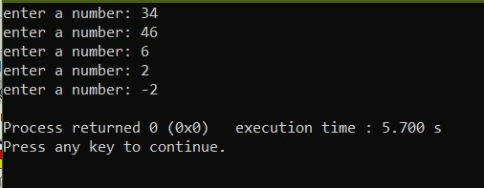

**TASK 2**

#include <iostream>

#include <math.h>

using namespace std;

int main()

{

double num1, num2;

char oprtr, ask;

do {

cout<<"Enter first number: ";

cin>>num1;

cout<<"Enter second number: ";

cin>>num2;

cout<<"Enter '+' for addition, '-' for subtraction, '*' for multiplication, '/' for division: '%' for modulo, 'p' for power: ";

cin>>oprtr;

cout<<"Answer is ";

switch(oprtr) {

case '+':

cout<<num1+num2;

break;

case '-':

cout<<num1-num2;

break;

case '*':

cout<<num1*num2;

break;

case '/':

cout<<num1/num2;

break;

case '%':

cout<<(int)num1%(int)num2;

break;

case 'p':

cout<<pow(num1, num2);

break;

}

cout<<endl<<"Want to calculate again? Enter 'y' for YES and 'n' for NO: ";

cin>>ask;

} while (ask == 'Y' || ask == 'y');

return 0;

}

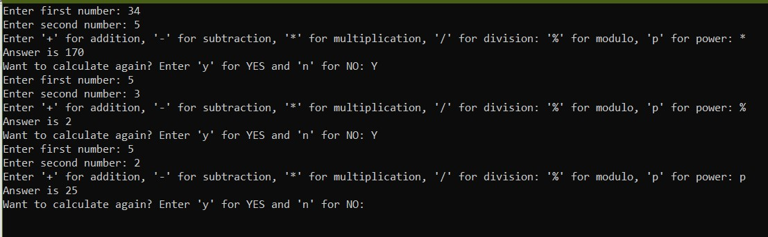

**TASK 3 (a)**

#include <iostream>

using namespace std;

int main()

{

int i = 2, sum=0;

while (i<=100) {

if (i%2==0) {

sum+=i;

}

i++;

}

cout<<"Sum of all even numbers is "<<sum;

return 0;

}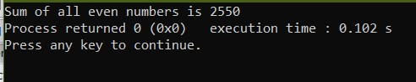

**TASK 3 (b)**

#include <iostream>

#include <math.h>

using namespace std;

int main()

{

int i = 1, sum=0;

while (i<=100) {

sum+=pow(i, 2);

i++;

}

cout<<"Sum of all squares between 1 and 100 is "<<sum;

}

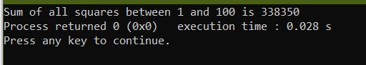

**TASK 4 (a)**

#include <iostream>

#include <math.h>

using namespace std;

int main()

{

int i = 0;

while (i<=20) {

cout<<pow(2, i)<<", ";

i++;

}

return 0;

}

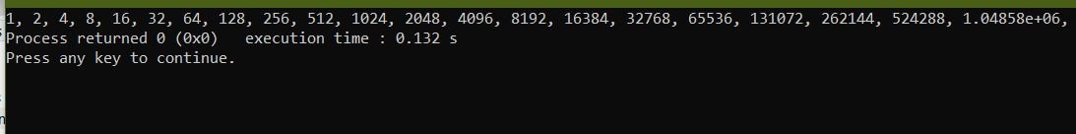

**TASK 4 (b)**

#include <iostream>

#include <math.h>

using namespace std;

int main()

{

int a, b, sum=0;

cout<<"Enter value of a: ";

cin>>a;

cout<<"Enter value of b: ";

cin>>b;

while (a<=b) {

if (a%2==1){

sum+=a;

}

a++;

}

cout<<"The sum of all odd numbers from a to b is "<<sum;

return 0;

}

